



 S.K.P ENGINEERING COLLEGE

Approved by AICTE & Affiliated to Anna University

NH 66, Somasipadi Post,Chinnakangiyanur, Tiruvannamalai,

Tamil Nadu-606611

**DEPARTMENT OF COMPUTER SCIENCE AND**

**ENGINEERING**

BACHELOR OF ENGINEERING 2024-2025

FIFTH SEMESTER

**PROJECT TITLE:**

**Project Created by:**Sureshkrishna.R,Surendhar.R,Surya.S,Surya.S

**Project Reviewed by:** Dr.M.Senthil

**College Code:** 5122

**Team ID** :NM2024TMID09258





 S.K.P ENGINEERING COLLEGE

Approved by AICTE & Affiliated to Anna University

**DEPARTMENT OF COMPUTER SCIENCE AND**

**ENGINEERING**

Certified that this is a bonafide record of work done by

Name :Sureshkrishna.R,Surendhar.R,Surya.S,Surya.S

University Reg No :512222104070, 512222104071,512222104072,

512222104073

Year / Semester : 3 / 5

Branch : CSE

Year : 2024-2025

**Staff-in-Charge Head of the Department**

Submitted for the Practical Examination held on ____________

**Internal Examiner External Examiner**

**Project Overview**

This project is focused on the development and implementation of a Lease Management System using Salesforce, designed to address the challenges of manual property lease tracking, tenant management, payment processing, and communication within the organization. The goal is to deliver a comprehensive solution that streamlines and automates various aspects of lease management, from contract creation to payment tracking, approval workflows, and reporting.

Through this project, we aim to enhance operational efficiency, data accuracy, and user experience for property managers, finance teams, and tenants. By leveraging Salesforce's powerful platform, we will create a solution that enables better tenant relationship management, ensures timely payments, and provides real-time visibility into key lease metrics. This will support the long-term goals of improving financial tracking, reducing administrative overhead, and scaling operations as the organization grows.

**2. Objectives:**

**Business Goals:**

1. **Improve Operational Efficiency:** 
   * **Goal:** Automate manual lease management processes to reduce administrative tasks, streamline workflows, and optimize time spent on routine tasks.
   * **Measure:** Reduce the time spent on manual data entry and tenant communication by 30% within the first 6 months of implementation.
2. **Enhance Data Accuracy and Centralization:**

**Goal:** Ensure accurate and up-to-date tenant, property, and payment data is centrally stored and accessible in Salesforce.

Achieve 100% accuracy in property and tenant records

within 3 months post-deployment, with real-time updates on lease statuses and payments.

1. **Increase Rent Collection and Timely Payments:** 
   * **Goal:** Automate payment reminders and overdue notifications to reduce late payments and improve rent collection efficiency.
   * **Measure:** Reduce overdue payments by 25% within the first 6 months, and achieve a 95% on-time payment rate.
2. **Improve Tenant Satisfaction and Communication:** 
   * **Goal:** Improve tenant communication with automated emails for lease renewals, payment reminders, and other key events.
   * **Measure:** Achieve a 20% improvement in tenant satisfaction scores related to communication and transparency (measured through surveys).
3. **Enable Scalable Growth:** 
   * **Goal:** Build a system that can scale with the organization’s growth, allowing for easy addition of new properties, tenants, and leases.
   * **Measure:** Enable the system to handle a 50% increase in properties and tenants without a corresponding increase in administrative resources or overhead.
4. **Improve Financial Visibility and Reporting:** 
   * **Goal:** Provide real-time reports and dashboards to track property occupancy, lease expirations, overdue payments, and overall financial health.
   * **Measure:** Achieve 100% adoption of real-time reports and dashboards by the finance and property management teams within 2 months of deployment.

**Specific Outcomes:**

1. **Automated Lease & Payment Management:** 
   * **Outcome:** A fully automated system to track leases, payments, and tenant communications.
   * **Measure:** 100% of lease renewals, payment reminders, and payment status updates are automated and sent to tenants.
2. **Custom Salesforce Objects & Relationships:** 
   * **Outcome:** Creation of custom objects for **Property**, **Tenant**, **Lease**, and **Payment**, with appropriate relationships (lookups) between them.

Successful creation and use of the custom objects and relationships by 100% of users within the first month of deployment.

1. **Approval Processes for Lease Renewals & Tenant Requests:**

o **Outcome:** Implementation of an automated approval process for lease renewals and other tenant-related requests (e.g., property vacancy checks, payment dispute resolution). o **Measure:** 100% of lease renewals and tenant requests go through an automated approval workflow, reducing manual intervention by 90%.

1. **Email Notifications and Alerts:** 
   * + **Outcome:** Automated email templates for tenant communications including reminders for payments, lease renewals, and approval/rejection notifications.
     + **Measure:** Achieve 95% successful delivery of email notifications and alerts, ensuring tenants receive timely updates.
2. **Real-Time Dashboards & Reporting:**

o **Outcome:** Custom Salesforce dashboards and reports to track key performance indicators (KPIs) such as overdue payments, property occupancy rates, and financial summaries. o **Measure:** Enable access to real-time dashboards and reports for property managers and finance teams, with at least 90% of users utilizing the dashboards for decision-making.

1. **Streamlined Tenant Onboarding & Lease Contracts:** 
   * + **Outcome:** A streamlined process for onboarding new tenants and generating lease contracts via templates and workflows in Salesforce.
     + **Measure:** 100% of new tenants are onboarded through the system, and lease contracts are generated automatically, reducing manual contract preparation by 80%.
2. **Tenant Payment Tracking and Reconciliation:** 
   * + **Outcome:** A system that tracks payments from tenants, records payment status (paid, pending, overdue), and integrates with accounting systems for financial reconciliation.
     + **Measure:** Achieve 95% accuracy in payment tracking, with real- time updates on payment status visible to finance teams and property managers.
3. **Seamless System Integration:**

o **Outcome:** Integration of Salesforce with existing accounting and CRM systems (if any) for seamless data flow and synchronization across platforms.

Achieve 100% integration between Salesforce and other

systems (e.g., accounting software) to ensure accurate and consistent data sharing.

**3. Salesforce Key Features and Concepts Utilized:**

**1. Custom Objects and Fields** o Lease Agreements: To track details such as terms, renewal dates, and associated parties.

* + - * Properties and Units: Represent physical assets linked to leases.
    1. **Workflow Automation** o Approval Processes: For lease approvals or amendments. o Scheduled Reminders: Automated notifications for lease expiration or payment deadlines.
    2. **Integration Capabilities** o Payment Gateways: For automated rent collection.
       - Third-party Property Management Tools: Seamless data exchange.

**4. Reports and Dashboards** o Lease Performance: Track revenue and occupancy rates.

* + - * Expiry Alerts: Visualize upcoming lease terminations.

**5. Document Management**

* + - * Integration with Salesforce Files or third-party systems for secure document storage and sharing.
    1. **Einstein Analytics** o Predictive Models: Analyze renewal likelihood or rent trends.
    2. **Role-Based Access** o Field-Level Security: Protect sensitive lease data.
       - Sharing Rules: Ensure appropriate access to leasing information.
    3. **Community Cloud** o Tenant Portals: For self-service access to lease documents, payment history, and requests.
    4. **Mobile Accessibility** o Salesforce App: Enable on-the-go lease and tenant management.

10.**Process Builder and Flows**

* + - Automate lease lifecycle tasks like renewals or termination workflows.

This suite of functionalities ensures efficient and scalable lease management within Salesforce.

**4. Detailed Steps to Solution Design for Lease Management:**

* 1. **Identify Business Requirements**

* + - Collect requirements from stakeholders to understand lease management processes (e.g., lease tracking, renewals, and reporting).
    - Define use cases, such as lease creation, rent collection, and tenant communication.

* 1. **Data Model Design**

* + - **Entities and Relationships:** 
      * **Custom Objects**:
        + Lease Agreement
        + Property
        + Unit
        + Tenant
        + Payment Schedule o **Relationships:**
        + Link Lease Agreements to Properties and Units

(lookup/master-detail relationships).

* + - * + Associate Tenants with Lease Agreements.
        + Relate Payment Schedules to Lease Agreements.
    - **Fields:** 
      * Define custom fields such as lease start/end dates, rent amount, security deposit, renewal terms, etc.
      * Use formula fields for calculated values (e.g., next payment due).
    - Create an ERD (Entity-Relationship Diagram) for visualization.

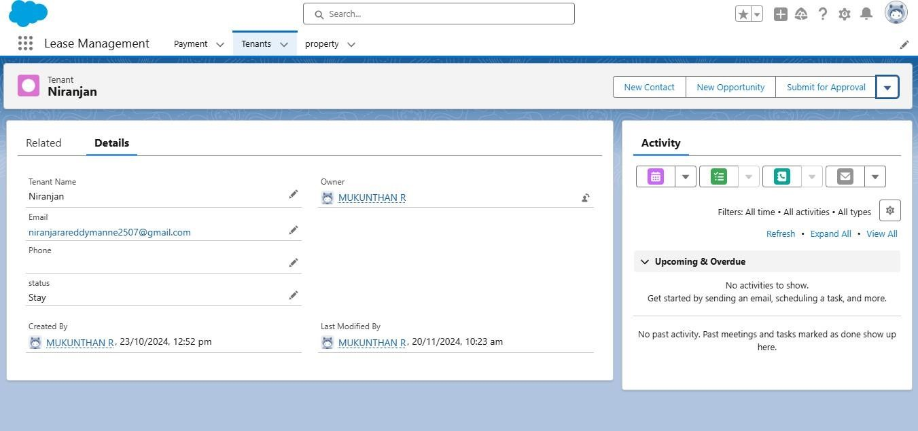

Fig1.1:Object-Tenant

* 1. **User Interface Design**

* + - **Layouts:** 
      * Use page layouts to group related fields (e.g., general lease info, payment history).
      * Add quick actions for common tasks like adding tenants or initiating renewals.
    - **Lightning Components:** 
      * Build custom components for features like a lease dashboard or payment calendar.
    - **Record Pages:** 
      * Customize Lightning Record Pages to include key lease details and related lists for easy navigation.
    - **Screenshots:** 
      * Provide screenshots of sample record pages, related lists, and component placements.

* 1. **Automation and Business Logic**

* + - **Workflow Rules and Processes:** 
      * Automate notifications for lease expiration or payment due.
    - **Flow Builder:** o Create guided processes for lease creation or renewal approval.
    - **Validation Rules:** 
      * Enforce business rules, such as ensuring end dates are after start dates.
    - Include detailed diagrams for automation logic and screenshots of flow configurations.

* 1. **Security and Access**

* + - **Profiles and Permission Sets:** 
      * Define roles such as Leasing Agent, Property Manager, and Tenant.
      * Use field-level security to control access to sensitive data like financials.
    - **Sharing Rules:** 
      * Ensure tenants only see their own lease information in the portal.

* 1. **Reporting and Dashboards**

* + - **Reports:** o Build reports for lease expirations, revenue, and occupancy rates.
    - **Dashboards:** 
      * Create visual summaries for key metrics, e.g., overdue payments or active leases.
    - Include sample report views and dashboard screenshots.

* 1. **Integration Design**

* + - Plan integrations with external systems like accounting software (e.g., QuickBooks) or payment gateways (e.g., Stripe).
    - Include data flow diagrams to show how data is exchanged between Salesforce and external systems.

* 1. **Testing and Validation**

* + - Prepare test cases for all major functionalities.
    - Perform unit testing, integration testing, and UAT (User Acceptance Testing).
    - Include examples of test case documents and screenshots from testing phases.

1. **Deployment and Training**

* + - Deploy the solution to production using change sets or CI/CD tools.
    - Provide training materials (e.g., user guides, videos) to ensure users understand the new system.

1. **Ongoing Monitoring and Enhancements** 
   * + Use Salesforce's monitoring tools to track system performance and data integrity.
     + Collect user feedback for continuous improvements.

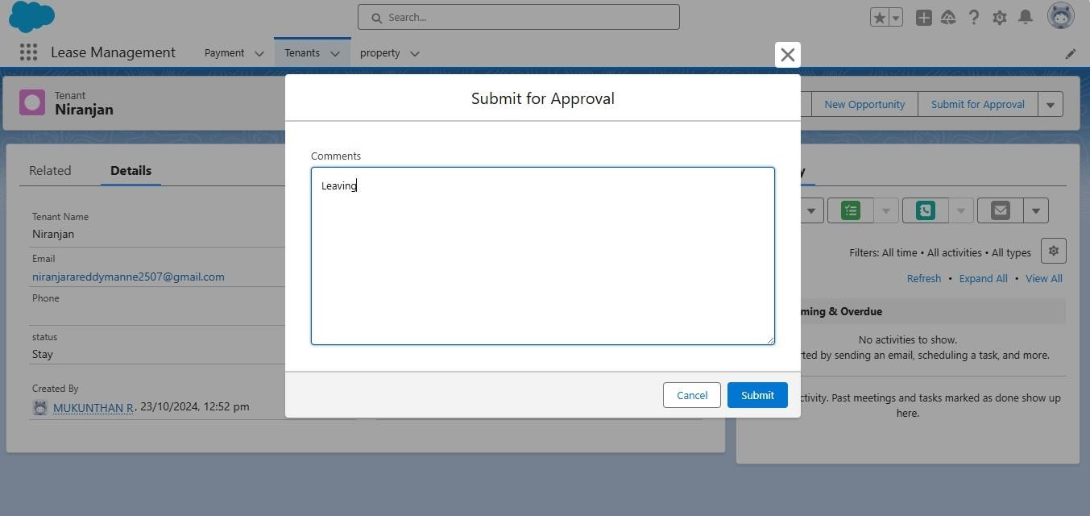

Fig1.2:Tenant approval

**5. Testing and Validation Approach for Lease Management:**

* 1. Unit Testing

Unit testing ensures that custom Salesforce code (Apex Classes, Triggers, and Batch Jobs) works as expected and meets business requirements.

**Key Activities in Unit Testing**

* + - **Apex Classes** o Write test methods to cover all scenarios of custom logic in Lease Management classes, such as:
      * + Lease Agreement creation and validation.
        + Renewal processing logic.
        + Payment schedule calculations.
      * Examples:
        + Test that the total rent amount is correctly calculated.
        + Test renewal logic for automatic date adjustments.
    - **Apex Triggers** 
      * Test triggers for:
        + Automating notifications when a lease is about to expire.
        + Generating related records (e.g., Payment Schedules upon Lease creation).
      * Verify that trigger logic handles bulk operations (data integrity in before insert, after update, etc.).
    - **Best Practices** o Ensure at least **75% code coverage**, with focus on business-critical logic.
      * Include assertions to validate expected outcomes. o Test edge cases, such as invalid data or extreme input values.
      * Mock callouts if integration logic is tested.

* 1. **User Interface Testing**

User Interface (UI) testing ensures that Lease Management screens and components function as intended for users.

Key Activities in User Interface Testing

* + - **Record Creation and Management** o Test creation of Lease Agreements, Properties, and Tenants via Salesforce UI.
      * Validate mandatory fields, default values, and picklist constraints.
    - **Lightning Components** o Verify that custom components display correct data, such as:
      * + Lease Agreement details.
        + Tenant information.
        + Payment due dates.
      * Test responsiveness across devices (desktop, tablet, mobile).
    - **Page Layouts** o Confirm that fields, sections, and related lists are visible to the correct roles (e.g., Leasing Agent vs. Tenant).
    - **Validation Rules** o Ensure validation messages appear correctly when invalid data is entered.
      * Example: Attempt to save a lease with a start date after the end date to trigger the rule.
    - **Process Automation** o Verify workflows, email alerts, and flow-guided steps by simulating actions, such as lease expiration or approval processes.

**Cross-Browser Testing**

* + - Ensure UI works consistently across major browsers (Chrome, Firefox, Safari, Edge).

**Mobile Testing**

* + - Validate the experience on the Salesforce mobile app, including navigation, data visibility, and action buttons.

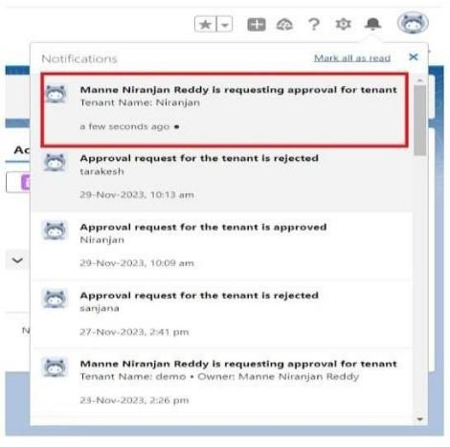

Fig1.3:Tenant approval request

* 1. **Documentation for Testing**

* + - **Test Case Design** o Create detailed test cases for each unit and UI component with:
      * + Test scenario descriptions.
        + Steps to reproduce.
        + Expected results.
        + Actual results.
    - **Defect Tracking** o Use tools like Jira or Salesforce's internal features to log and manage bugs found during testing

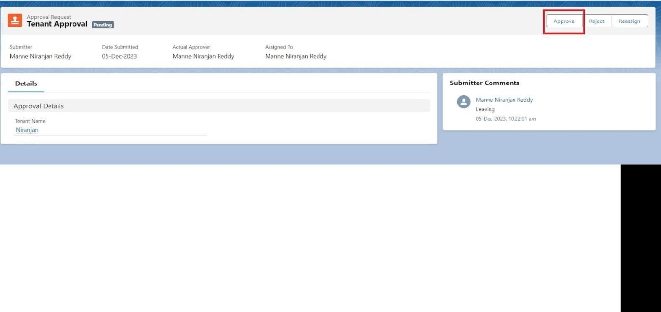

.

Fig1.4:Customer Tennant Approved

**6. Key Scenarios Addressed by Salesforce in the Implementation Project:**

**1. Lease Agreement Lifecycle Management**

* + - **Use Case:** 
      * Create, modify, and terminate lease agreements with predefined terms and conditions.
    - **Salesforce Features Utilized:** 
      * Custom Objects for Lease Agreements. o Flows for guided creation and modification.
      * Automation to trigger lease termination processes.

**2. Automated Payment Tracking**

* + - **Use Case:** 
      * Schedule, monitor, and reconcile rent payments linked to lease agreements.
    - **Salesforce Features Utilized:** 
      * Payment Schedule records linked to Lease Agreements.
      * Workflows and Flows for payment due reminders and notifications.
      * Integration with payment gateways (e.g., Stripe or PayPal).

**3. Lease Expiration and Renewal Alerts**

* + - **Use Case:** 
      * Notify property managers and tenants about upcoming lease expirations and automate renewal offers.
    - **Salesforce Features Utilized:** 
      * Time-based workflows for expiration reminders. o Flow Builder for automated renewal processes. o Dashboards to visualize lease expiration timelines.

* 1. **Property and Unit Management**

* + - **Use Case:** 
      * Maintain a database of properties and units linked to lease agreements.
    - **Salesforce Features Utilized:** 
      * Custom Objects for Properties and Units.
      * Lookup relationships between Properties, Units, and Lease Agreements.
      * Reports to track property occupancy rates.

* 1. **Tenant Relationship Management**

* + - **Use Case:** 
      * Manage tenant information, communication, and service requests.
    - **Salesforce Features Utilized:** 
      * Contact records linked to Lease Agreements. o Community Cloud for tenant self-service portals.
      * Case Management for handling tenant inquiries and issues.

* 1. **Financial Reporting and Revenue Analysis**

* + - **Use Case:** 
      * Generate financial reports to track revenue from leases and outstanding payments.
    - **Salesforce Features Utilized:** 
      * Reports for rent collection performance and overdue payments.
      * Dashboards for visualizing total revenue, monthly cash flow, and lease income trends.

* 1. **Legal Compliance and Document Management**

* + - **Use Case:** 
      * Store and manage legal documents associated with lease agreements.
    - **Salesforce Features Utilized:** 
      * Salesforce Files for secure document storage.
      * Validation rules to enforce data entry compliance with legal standards.

* 1. **Role-Based Access Control**

* + - **Use Case:** 
      * Ensure property managers, leasing agents, and tenants can only access relevant information.
    - **Salesforce Features Utilized:** 
      * Profiles, Roles, and Sharing Rules for data security.
      * Field-level security to protect sensitive financial details. **9. Performance Metrics and KPIs**

* + - **Use Case:** 
      * Monitor key performance indicators (KPIs) like occupancy rates, average lease duration, and rent collection efficiency.
    - **Salesforce Features Utilized:** 
      * Einstein Analytics for advanced data visualization and predictive insights.
      * Custom reports and dashboards for ongoing monitoring.

**10. Integration with External Systems**

* + - **Use Case:** 
      * Synchronize Salesforce data with external systems for accounting, payments, and legal compliance.
    - **Salesforce Features Utilized:** 
      * APIs for integration with systems like QuickBooks, Stripe, or DocuSign.
      * MuleSoft or other middleware for seamless data exchange.

**7. Conclusion:**

**Summary of Achievements**

The Salesforce implementation for Lease Management has successfully streamlined and automated critical aspects of the leasing lifecycle. Key accomplishments include:

* + 1. **Comprehensive Lease Lifecycle Management** o Implemented a robust system to manage lease agreements, from creation and amendments to renewals and terminations.

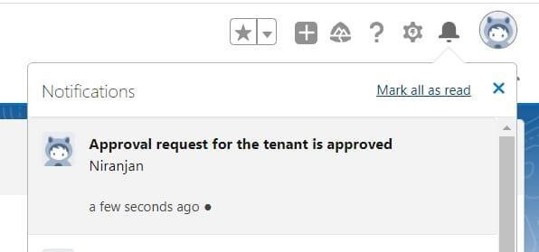

o

Fig1.5:Tenant final approved

* + 1. **Automated Payment Processes** o Enabled scheduled rent tracking, payment reminders, and overdue alerts, reducing manual oversight and improving cash flow management.
    2. **Efficient Expiration and Renewal Workflows** o Automated notifications and streamlined renewal processes, ensuring timely follow-ups and improved lease retention rates.
    3. **Enhanced Property and Tenant Management** o Centralized information for properties, units, and tenants, improving operational visibility and collaboration.
    4. **Actionable Insights and Reporting** o Delivered custom reports and dashboards to monitor revenue, lease performance, and occupancy metrics, supporting data-driven decision-making.
    5. **Improved User Experience** o Provided intuitive interfaces and mobile accessibility for leasing agents, property managers, and tenants, enhancing productivity and satisfaction.
    6. **Secure and Scalable Solution** o Ensured role-based access, field-level security, and compliance with legal requirements, enabling a reliable and scalable system for lease management.
    7. **Integration with External Systems**

• Established seamless connections with payment gateways and accounting systems for end-to-end process automation.

**8. Reference:**

International Journal of Advanced Research in Science, Communication and Technology (IJARSCT): [https://ijarsct.co.in/Paper7646.pdf.](https://ijarsct.co.in/Paper7646.pdf)

Github lease Management:

<https://github.com/rSureshKrishna/LEASE-MANAGEMENT.git>

Salesforce documentation:

[Build an Integrated Real Estate CRM for Tenant Management.](https://www.salesforce.com/)